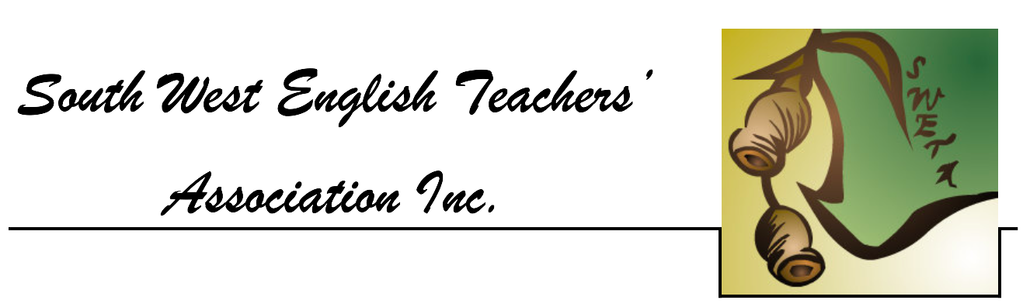

**Practice Western Australian Certificate of Education**

**ATAR course examination, 2018**

**Question/Answer booklet**

**YEAR 12**

**ATAR ENGLISH**

Place your student identification label in this box.

Student number: In figures

In words ________________________________________

________________________________________

**Time allowed for this paper**

Reading time before commencing work: ten minutes

Working time: three hours

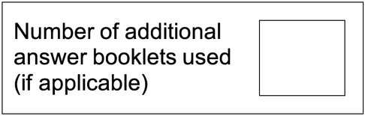**Materials required/recommended for this paper**

**To be provided by the supervisor**

This Question/Answer booklet

**To be provided by the candidate**

Standard items: pens (blue/black preferred), pencils (including coloured), sharpener, correction fluid/tape, eraser, ruler, highlighters

Special items: nil

**Important note to candidates**

No other items may be taken into the examination room. It is **your** responsibility to ensure that you do not have any unauthorised material. If you have any unauthorised material with you, hand it to the supervisor **before** reading any further.

**Structure of this paper**

|  |  |  |  |  |  |
| --- | --- | --- | --- | --- | --- |
| Section | Number of questions available | Number of questions to be answered | Suggested working time (minutes) | Marks available | Percentage of examination |
| Section One  Comprehending | 3 | 3 | 60 | 30 | 30 |
| Section Two Responding | 6 | 1 | 60 | 40 | 40 |
| Section Three Composing | 5 | 1 | 60 | 30 | 30 |
|  |  |  |  | **Total** | 100 |

**Instructions to candidates**

1. The rules for the conduct of the Western Australian Certificate of Education ATAR course examinations are detailed in the *Year 12 Information Handbook 2018.* Sitting this examination implies that you agree to abide by these rules.
2. Write your answers in the Question/Answer booklet.
3. You must be careful to confine your answers to the specific questions asked and to follow any instructions that are specific to a particular question.
4. Supplementary pages for the use of planning/continuing your answer to a question have been provided at the end of this Question/Answer booklet. If you use these pages to continue an answer, indicate at the original answer where the answer is continued, i.e. give the page number.
5. You must not use texts from Section One to answer questions from Section Two.

**Section One: Comprehending 30% (30 Marks)**

In this section, there are **three** texts and **three** questions. Answer **all** questions.

You are required to comprehend and analyse unseen written and visual texts and respond concisely in approximately 200-300 words for each question.

Suggested working time: 60 minutes.

**Question 1 (10 Marks)**

Discuss how the construction of the setting reveals an idea about the central character in Text 1.

**Question 2 (10 Marks)**

Compare the ways Text 1 and Text 2 use the Australian landscape to create a response.

**Question 3 (10 Marks)**

Explain how your response to Text 3 has been shaped by its language features.

**Text 1**

*This passage is an excerpt from a short story titled* After Noumea *by Robert Drewe.*

Recovering from his breakdown late that winter, Brian rented a weatherboard off-season holiday cottage at Palm Beach with two separate ocean views to guarantee serenity. A trailing edge of Cyclone Anna lashed his car as he drove up the peninsula, and on arrival he immediately lit a fire to keep the storm at bay and arranged himself in front of it. Below the cottage a high surf crashed on the beach, Eucalypt branches scraped along the roof guttering. Still tense from the drive he drank two brandies, cursorily read a magazine and went to bed.

Currawongs and kookaburras woke him early, the day was grey but fine, with a clear light. Right away he was determined to make a schedule to live and work by. This took him the morning. Sharp at noon, as set out in his new schedule, he left for a walk down the gravel track through high trees to the beach.

Just around the first bend in the track he was ambushed by a blue heeler. Crouching low without barking, the dog ran around him to attack his legs from behind. Brian kicked out and it bit him on the calf though his jeans kept it from breaking the skin. He arrived at the beach still angry at the dog. Walking and jogging in alternate spurts, he became quickly puffed, his feet sinking into the soft sand. The storm had brought in dead fish and sea birds, plastic bottles, amorphous lumps of jelly from some marine invertebrate. Fine russet sand grains stuck to his feet and legs. Waves broke close inshore and a haze of moisture hung over the headland.

Returning to the cottage, breathing hard as he climbed the hill, he was again attacked by the dog. Furious, he yelled and ran wildly at it. The dog stood stunned at his reaction and then fled. From a safe distance it barked and showed its front teeth at him. Climbing the rock steps to the cottage he was surprised how tense and angry it had made him.

**Question 1 (10 Marks)**

Discuss how the construction of the setting reveals an idea about the central character in Text 1.

**This page has been left blank intentionally**

**Text 2**

*This is a black and white reproduction of a still from the Australian TV series* Wake in Fright *produced in 2017.*

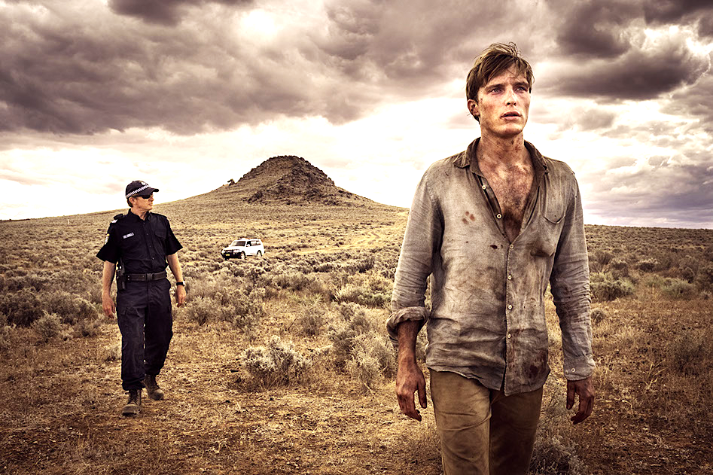**Question 2 (10 Marks)**

Compare the ways Text 1 and Text 2 use the Australian landscape to create a response.

**This page has been left blank intentionally**

**Text 3**

*This article was published in* The Big Issue *and is titled “It’s Not a Race” by Lorin Clarke.*

We're entering it now, the part of the year where, if 2018 were a racehorse, we'd be in the final stretch. Belting around that last bend, a choppy mess of mud and muscle. You already know, barring a photo finish or a last-minute drama, what kind of a year it's going to turn out to be. Squinting at the finish line from here, you can probably already tell. Surprising and thrilling and momentous? A grab-the-stranger-next-to-you-and-hug-them kind of a year? Will you make it on the news, elated and a little bit drunk? "Just can't believe it! What a moment in history!" Or has the horse been spooked? Is it bucking its rider? Will everybody unlucky enough to have had hope in it trudge home with their shoes in their hands, bedraggled fascinators abandoned on fenceposts like portentous* windsocks, warning us against the same fate next time? Sorry, what was the question?

Dunno. Point is, we’re almost into the second half of the year now. So, whether things are going terribly, or not so terribly, or kind of alrightly (not a word, shoosh), remember that your life is bigger than the calendar year and smaller than the world. Look around you. Life is full of little things that have nothing to do with how your year is going.

Things like glancing up at the sunset when you’re looking down and forgot to notice. It’s like there’s a free show happening right in front of you and you weren’t paying attention.

Also free: singing. Might not be your favourite thing to do but if you turn the music up and make yourself sing along, chances are things will be looking up about three minutes in.

*portentous: of massive significance

**Question 3 (10 Marks)**

Explain how your response to Text 3 has been shaped by its language features.

**End of Section One**

**This page has been left blank intentionally**

**Section Two: Responding 40% (40 Marks)**

In this section, there are **six** questions. Answer **one** question.

Your response should demonstrate your analytical and critical thinking skills with reference to any text or text type you have studied.

Suggested working time: 60 minutes.

**Question 4 (40 Marks)**

Discuss how an understanding of context promotes empathy for individuals or groups represented in at least **one** text.

**Question 5 (40 Marks)**

Compare the ways **two** texts use conventions of different genres to achieve a similar response from an audience.

**Question 6 (40 Marks)**

Evaluate the effectiveness of stylistic choices in shaping your attitude towards issues in **two** or more texts.

**Question 7 (40 Marks)**

Explore the ways in which at least **one** text challenges or reinforces your perspective on a controversial issue.

**Question 8 (40 Marks)**

Describe how voice is constructed in at least **one** text to achieve a particular purpose.

**Question 9 (40 Marks)**

Explain how at least **one** text conforms to a genre in order to reflect a particular context.

Question number: **________________**

**End of Section Two**

**Section Three: Composing 30% (30 Marks)**

In this section, there are **five** questions. Answer **one** question.

You are required to demonstrate writing skills by choosing a form of writing appropriate to a specific audience, context and purpose.

Suggested working time: 60 minutes.

**Question 10 (30 Marks)**

*All the things one has forgotten scream for help in dreams.* Elias Canetti.

Use this as the opening line of an interpretive piece of writing on an event or issue in society that needs help or attention.

**Question 11 (30 Marks)**

Use the image below to create an imaginative text that represents a group or individual through a sustained voice.

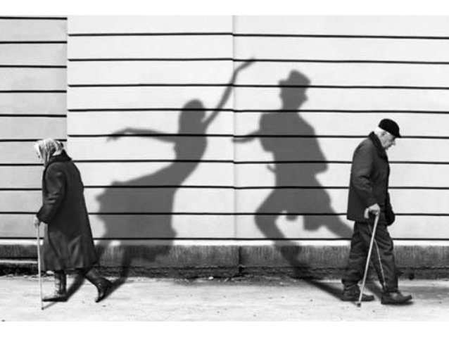

**Question 12 (30 Marks)**

In a form of your choice, compose a text that explores an idea from an unexpected perspective.

**Question 13 (30 Marks)**

Create a persuasive text that uses structural and language features to encourage a particular audience to react to a controversial issue.

**Question 14 (30 Marks)**

Inspired by the image below, compose an imaginative text that uses generic conventions to evoke a particular mood.

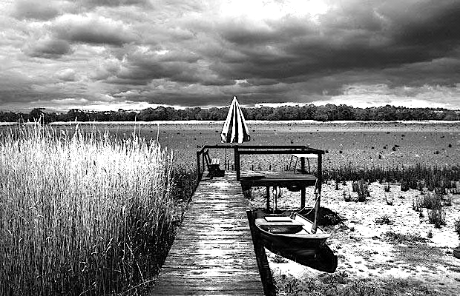

**End of questions**

Question number: **________________**

Additional working space

Question number: **________________**

Additional working space

Question number: **________________**

Additional working space

Question number: **________________**

**ACKNOWLEDGEMENTS**

**Text 1** Excerpt from: Drewe, R. (2009). ‘ After Noumea’. *The Bodysurfers*. Australia: Penguin Group, pp.

**Text 2** Still image from: Irwin, S.M. (Writer.), & Stenders, K. (Dir.). (2017). *Wake in the Fright* [Miniseries]. Retrieved July 5, 2018, from https://stack.com.au/film-tv/tv-review/wake-fright-2017-dvd/

**Text 3** Clarke, L., ‘It’s Not a Race’. *The Big Issue,* No.563., Published: 1-14 June 2018

**Question 11** Jardin, F., [Dancing shadows and missed opportunities] [Photograph]. Retrieved July 10, 2018, from https://tanyagrove.files.wordpress.com/2011/12/by-fred-jardin.jpg

Copyright **©** South West English Teachers’ Association 2018.